**Project Planning Phase**

**Project Planning Template (Product Backlog, Sprint Planning, Stories, Story points)**

|  |  |
| --- | --- |
| Date | 1 November 2022 |
| Team ID | PNT2022TMID04763 |
| Project Name | Project – IoT based safety gadget for child safety monitoring and notification |
| Maximum Marks | 8 Marks |

**Product Backlog, Sprint Schedule, and Estimation (4 Marks)**

Use the below template to create product backlog and sprint schedule

|  |  |  |  |  |  |  |
| --- | --- | --- | --- | --- | --- | --- |
| **Sprint** | **Functional Requirement (Epic)** | **User Story Number** | **User Story / Task** | **Story Points** | **Priority** | **Team Members** |
| Sprint-1 | Registration | USN-1 | I can sign up for the application as a user by providing my email address, a password, and a password confirmation. | 5 | High | Suba Jai Varthini |
| Sprint-1 |  | USN-2 | When I register for the application as a user, I will get a confirmation email. | 5 | High | Sri Harini |
| Sprint-2 |  | USN-3 | I can sign up for the application as a user through Facebook. | 10 | Low | Srivarshan |
| Sprint-1 |  | USN-4 | I can sign up for the application as a user through Gmail. | 5 | Medium | Suriya |
| Sprint-1 | Login | USN-5 | I can access the application as a user by providing my email address and password. | 5 | High | Suba Jai Varthini |
| Sprint-2 | Dashboard | USN-6 | As a user, I can see the temperature, GPS tracker, alarm in case of  Emergency and notification options. | 10 | High | Sri Harini,  Srivarshan |
| Sprint-3 | Interfacing with mobile application | USN-7 | As a user, I can send alarm sound to alert the bystanders | 10 | Low | Suriya,  Suba Jai Varthini |
| Sprint-3 |  | USN-8 | As a user, I can see the temperature, location of my child | 10 | High | Sri Harini,  Srivarshan |
| Sprint-4 | Data base collection | USN-9 | As a user, I want the data to be stored | 5 | Medium | Suriya , Suba Jai Varthini |

|  |  |  |  |  |  |  |
| --- | --- | --- | --- | --- | --- | --- |
| **Sprint** | **Functional Requirement (Epic)** | **User Story Number** | **User Story / Task** | **Story Points** | **Priority** | **Team Members** |
| Sprint 4 | Mobile application | USN-10 | As a user, I can sense the child safety device using sensor and monitor using mobile app | 15 | Medium | Sri Harini,  Srivarshan |

**Project Tracker, Velocity & Burndown Chart: (4 Marks)**

|  |  |  |  |  |  |  |
| --- | --- | --- | --- | --- | --- | --- |
| **Sprint** | **Total Story Points** | **Duration** | **Sprint Start Date** | **Sprint End Date (Planned)** | **Story Points Completed (as on Planned End Date)** | **Sprint Release Date (Actual)** |
| Sprint-1 | 20 | 6 Days | 24 Oct 2022 | 29 Oct 2022 | 20 | 29 Oct 2022 |
| Sprint-2 | 20 | 6 Days | 31 Oct 2022 | 05 Nov 2022 | 20 | 05 Nov 2022 |
| Sprint-3 | 20 | 6 Days | 07 Nov 2022 | 12 Nov 2022 | 20 | 12 Nov 2022 |
| Sprint-4 | 20 | 6 Days | 14 Nov 2022 | 19 Nov 2022 | 20 | 19 Nov 2022 |
|  |  |  |  |  |  |  |
|  |  |  |  |  |  |  |
|  |  |  |  |  |  |  |
|  |  |  |  |  |  |  |

**Velocity:**

Imagine we have a 10-day sprint duration, and the velocity of the team is 20 (points per sprint). Let’s calculate the team’s average velocity (AV) per iteration unit (story points per day)



**Burndown Chart:**

A burn down chart is a graphical representation of work left to do versus time. It is often used in agile [software development m](https://www.visual-paradigm.com/scrum/what-is-agile-software-development/)ethodologies such as [Scrum.](https://www.visual-paradigm.com/scrum/scrum-in-3-minutes/) However, burn down charts can be applied to any project containing measurable progress over time.

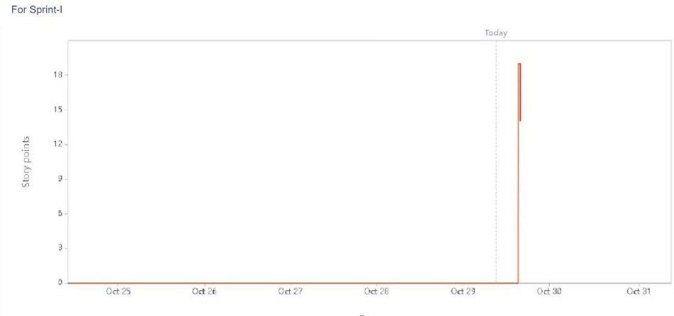

**Tool used: JIRA software**